Experimental Results--No.6

Total Time：120 min

1. Use Case Diagram

Time：8 min

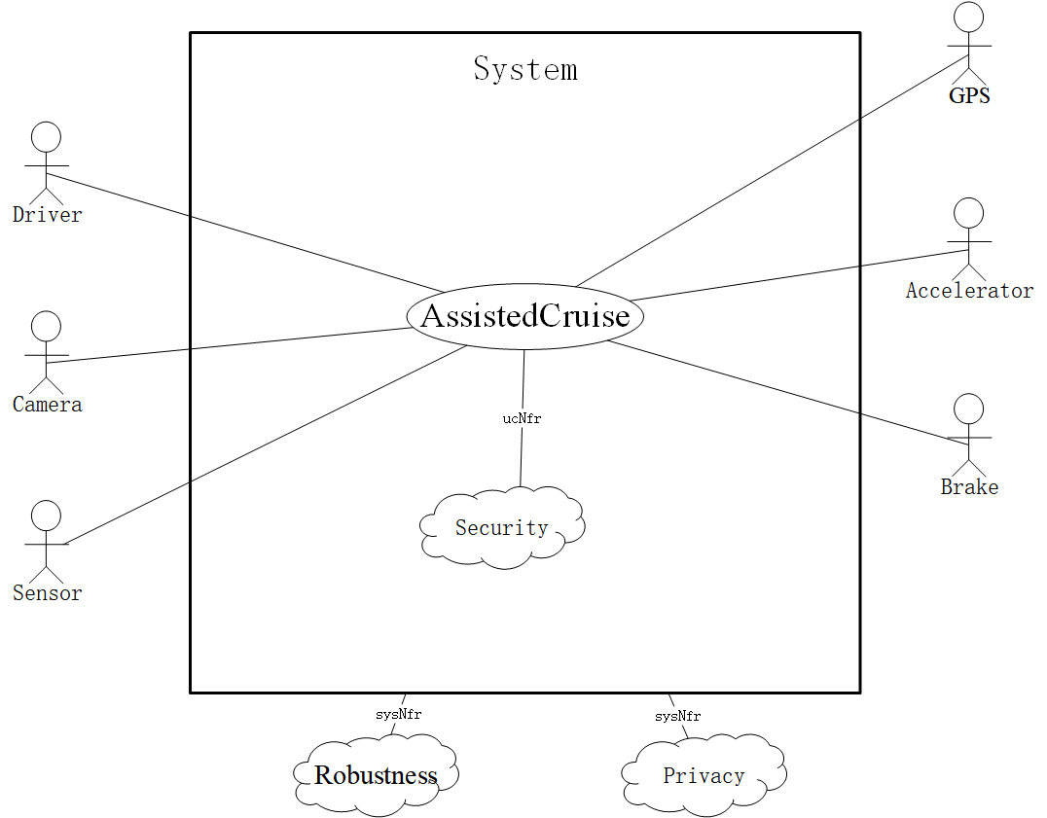

1. System Sequence Diagram

Time：65min

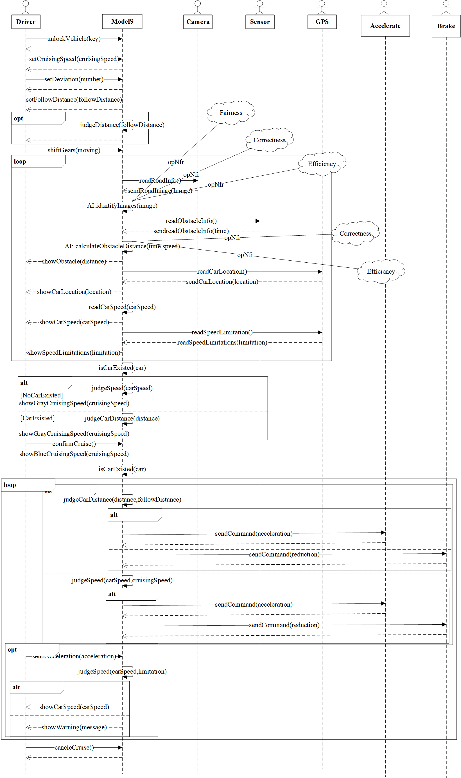

1. Conceptual Class Diagram

Time：27min

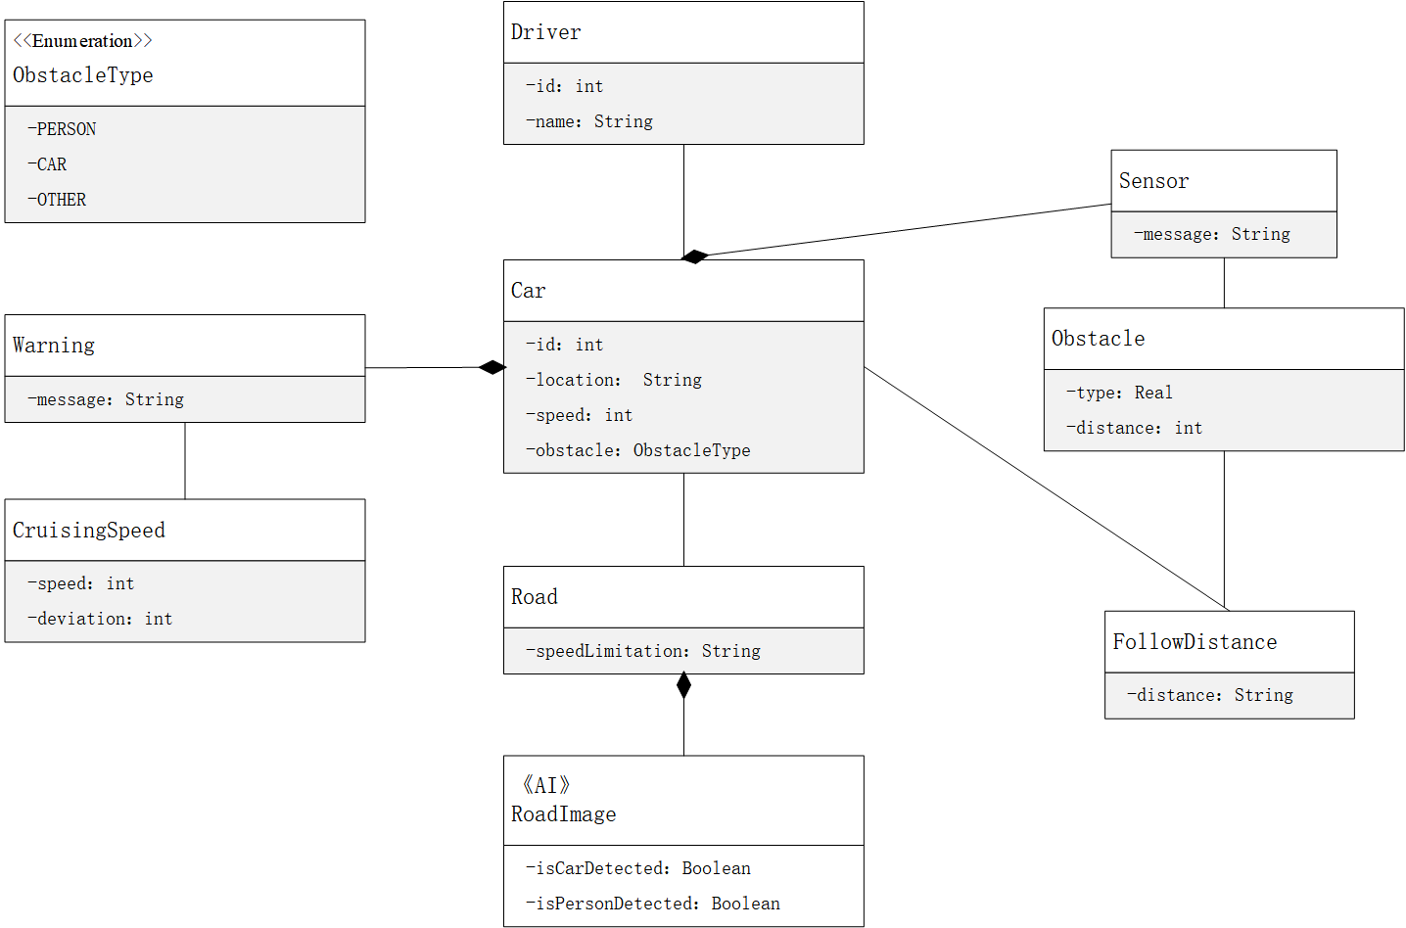

1. Context Diagram

Time：10min

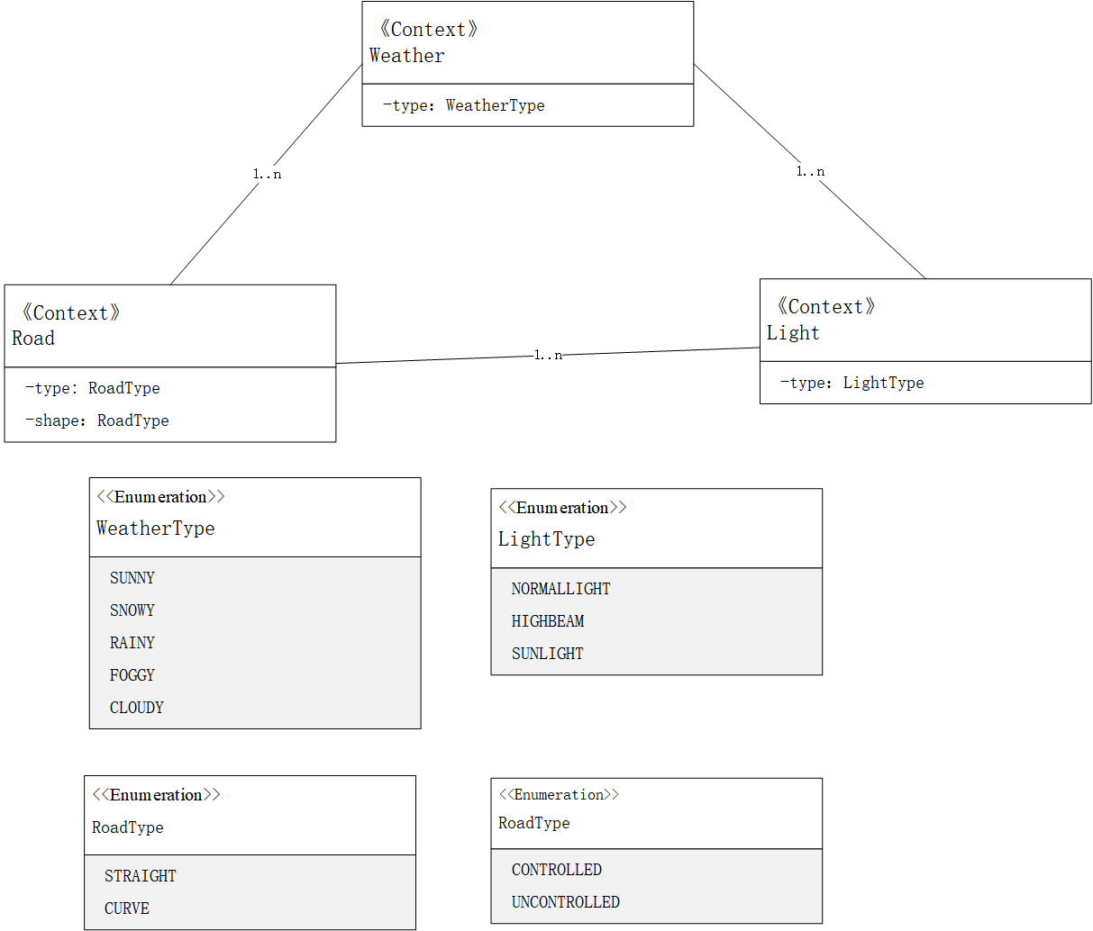

1. Machine Learning Diagram

Time：10min

